


LEGAL OFFICE PROCEDURES
(245)

STATE – 2020

Part I OBJECTIVE
Written Test (30 questions @ 5 points each) ____________(150 points)
Part II PRODUCTION
Job 1 – Affidavit ____________(100 points)
Job 2 – Letter ____________(100 points)

TOTAL POINTS ____________(350 points)

Judges/Graders: Please double check and verify all scores and answer keys!

Property of Business Professionals of America.
May be reproduced only for use in a Business Professionals of America Workplace Skills Assessment Program competition.

GENERAL INSTRUCTIONS

- Answer the objective questions using the Scantron scoring sheet provided.

- Make certain this test booklet contains Jobs 1 and 2.

- Key all Jobs according to the instructions given.

- Correct any obvious keyboarding errors and incorporate any editing notations.

- Correct any errors in formatting. Use formatting shown in the Style & Reference Manual.
- For any problem where you would normally key your reference initials, key your contestant number. Your name or initials should NOT appear on any work you submit.

- Key your contestant number and job number as the footer in the lower left-hand corner of all work submitted unless otherwise specified.

Example:
99-9999-9999
Job 1

- If you finish before the end of the 60 minutes of testing, notify the proctor. In the event of a tied score, time may be a factor in determining the winner.

- When turning in your materials, place your scoring sheet on top of your jobs. The jobs should be arranged in numerical order.

Production Standards

0 Errors | 100 points
1 Error | 90 points
2 Errors | 70 points
3 Errors | 50 points
4+ Errors | 0 points

PART I – OBJECTIVE

SECTION 1 – LEGAL KNOWLEDGE
SECTION 2 – WORKING IN A LEGAL OFFICE

1. | c |  | 11. | d |  | 21. | d
2. | b |  | 12. | b |  | 22. | c
3. | a |  | 13. | d |  | 23. | b
4. | d |  | 14. | a |  | 24. | a
5. | a |  | 15. | a |  | 25. | d
6. | c |  | 16. | d |  | 26. | c
7. | d |  | 17. | a |  | 27. | d
8. | c |  | 18. | a |  | 28. | b
9. | c |  | 19. | d |  | 29. | b
10. | c |  | 20. | a |  | 30. | a

PART II – PRODUCTION

Your role in the production part of this test is to work for the law firm of Wooster & Hunt as a legal office assistant. You have been asked to prepare two documents for attorney Randall Nebeker:

Job 1: Letter to a new client, the Chicago NewsDaily, from Randall Nebeker
Your contact at the Chicago NewsDaily is Ms. Lucille Sampleton, who is the Associate Counsel for the NewsDaily.

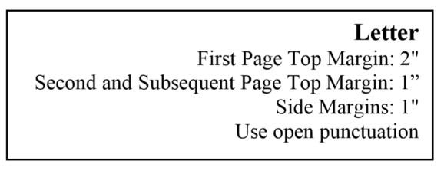

[current date] (use current date unless otherwise specified)

(QS)

Ms. Lucille Sampleton
Associate Counsel
Chicago NewsDaily
1400 Ohio Avenue
Chicago, IL 60601-1234
(DS)
Dear Lucille
(DS)
RETAINER FEE
(DS)
It was a pleasure to meet you yesterday and discuss the details of the NewsDaily’s acquisition of property in Rockford. Our firm is pleased you chose us to handle the transactions and business end of this acquisition.
(DS)
We discussed that the retainer will be $50,000.00. We will prepare and submit monthly statements to you that detail our work and expenses for the month. The monthly statement will request you to remit the amount that would keep your retainer at $50,000.00 level. I have instructed my assistant to prepare the retainer fee agreement and send it to you by the end of the week.
(DS)
I look forward to working with you over the coming months.
(DS)
Sincerely

(QS)

Jonathan Owens
(DS)
Contestant #

Contestant #
Job 1
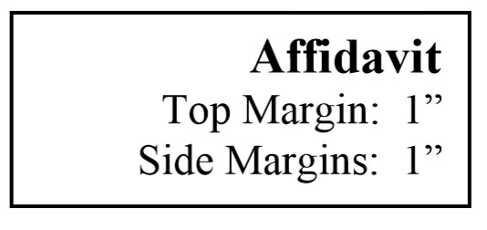
Job 2: Affidavit

Follow any proofreading symbols given, and correct any obvious errors in grammar, spelling, capitalization, number style, and word choice.
Follow the contest and format guidelines in the WSAP, the BPA Style & Reference Manual, and the General Instructions provided with this event.

STATE OF ILLINOIS (bold)
(DS)
COUNTY OF CLARK (bold)
(DS)

AFFIDAVIT (bold)
(DS)
I, Randall J. Nebeker, upon oath, state as follows:
(DS)
- On Monday, April 1, 2020, I provided to Lucille Sampleton at the Chicago NewsDaily
the entire file my office has compiled for our former client the Chicago NewsDaily.
- Wooster & Hunt did not keep copies of any documents that belong to our former
client.
- Wooster & Hunt kept copies of all documents that were generated from my office.
These include billing statements, notes, and any research performed by us or our designee(s).

(QS)

________________________ (2” line)
Randall J. Nebeker
(DS)
WITNESS my hand and official seal in the County and State aforesaid this _______ day of
(DS)
_________________ (1½" line), 20__.

(QS)

________________________ (2” line)
Notary Public
Contestant #
Job 2

